Letrell Hodge

3/25/2023

ASD190-22

Edit the following PHP class definition to add a public attribute named attribute1.

class MyClass

2. Define an object named $c that instantiates an instance of the class MyClass, using no parameters.

3. Modify the following code to specify that the B class is a subclass of the A class.

class B ____ A {}

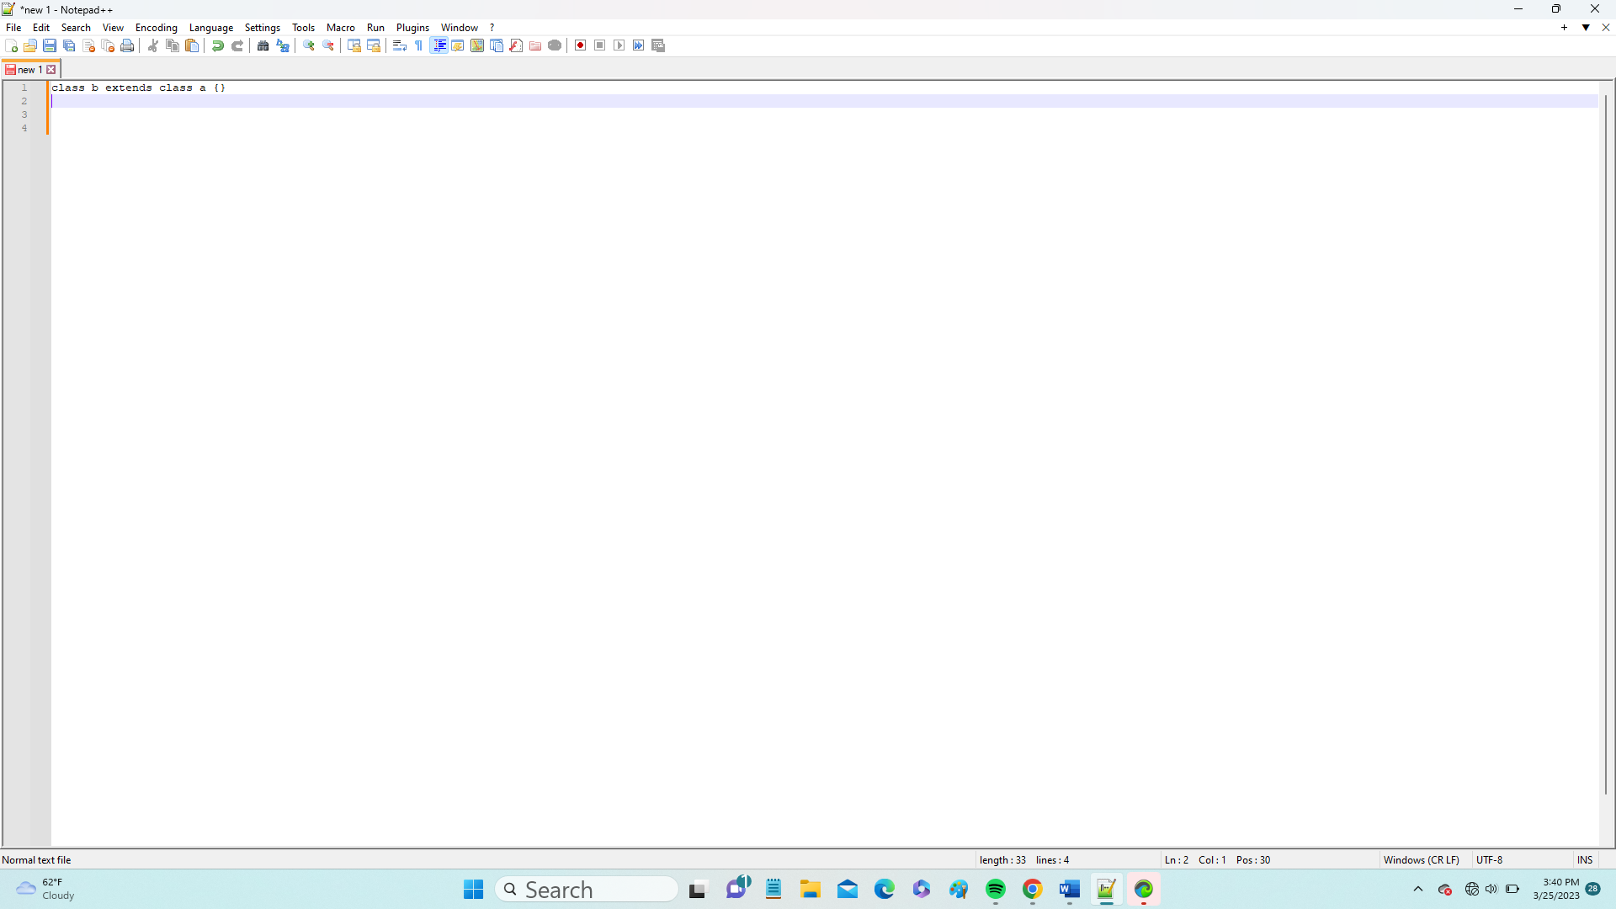

4. Define a PHP variable named $c that is a copy of object $b of the same class with the same attribute values.

5. Create a namespace named orders to hold all your order-related PHP code.

Namespace orderNamespace{